Section Tuba Audition Repertoire
January 6, 2019

Jerry Junkin, Artistic Director

*All performances should be on contra bass tuba.
**Play the bottom octave in excerpts where applicable.

Prepared Solo: Sonata for Tuba and Piano (Bruce Broughton): Movement 1
Excerpts:
- First Suite in E flat (Holst)
- J’ ai été au bal (Grantham): solo
- J’ ai été au bal (Grantham)
- Church Windows (Respighi) Movement II, San Michele Arcangelo: L to bar 198
- Church Windows (Respighi) Movement III, Il Mattutino di Santa Chiara: S to the end
- Symphony in B flat (Hindemith), Movement I: bar 123 to letter K
- Symphony in B flat (Hindemith), Movement I: bar 203 to bar 212
- Eternal Father, Strong to Save (Claude T. Smith): letter H to 7 bars after letter I
- Lincolnshire Posy (Grainger) Rufford Park Poachers: pick-up to bar 51 to bar 83
- Overture to Rienzi (Wagner/Patterson)
- Overture to Rienzi (Wagner/Patterson)
- Toccata Marziale (Vaughan Williams)
- Toccata Marziale (Vaughan Williams)
- March, “Entry of the Gladiators” (Fucik/Tuschla)
- March, “Entry of the Gladiators” (Fucik/Tuschla)
- Music from Far and Away (John Williams): bar 180 to bar 228

- First Suite in E flat (Holst)
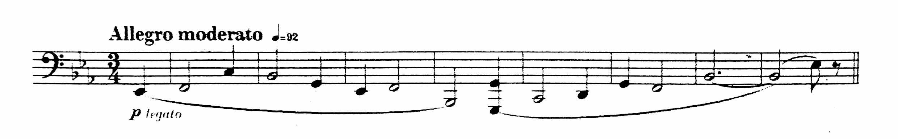

- Jai été au bal (Grantham): solo
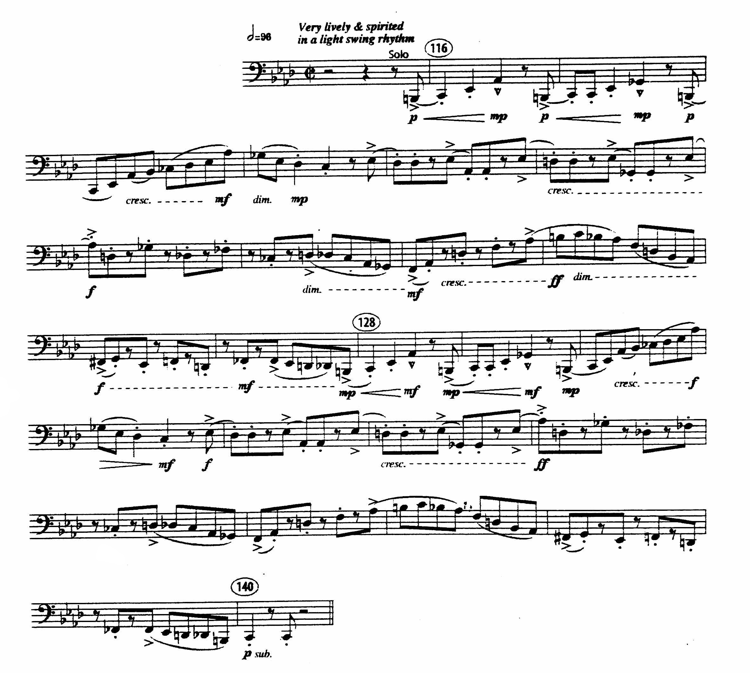
- Jai été au bal (Grantham)
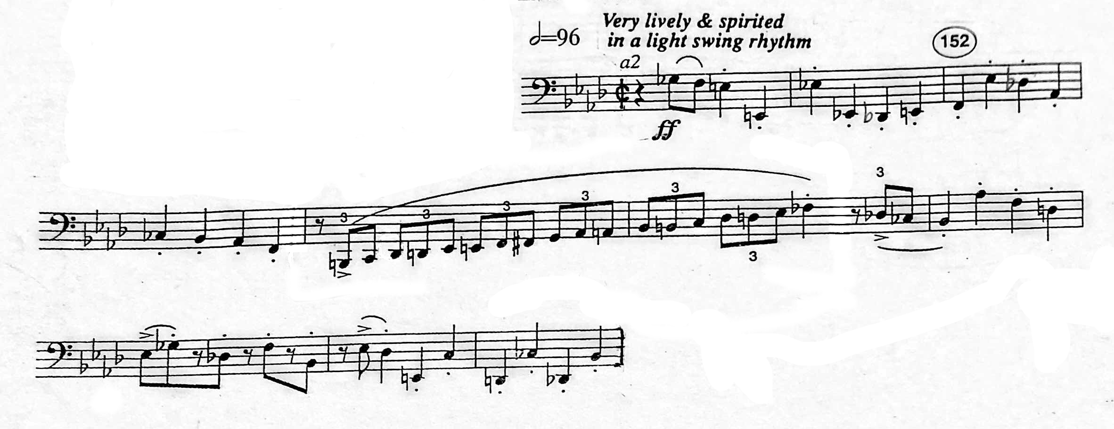
- Church Windows (Respighi) Movement II, San Michele Arcangelo: L to bar 198
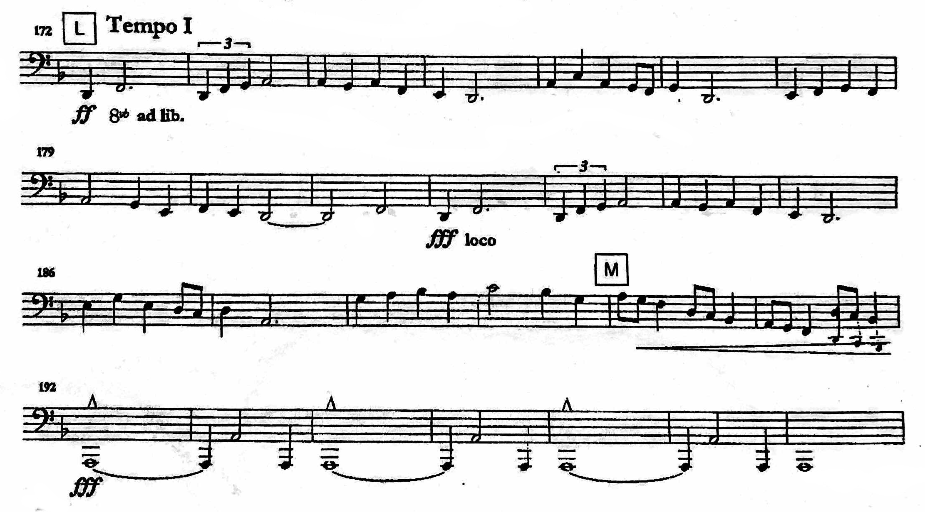
- Church Windows (Respighi) Movement III, Il Mattutino di Santa Chiara: S to the end
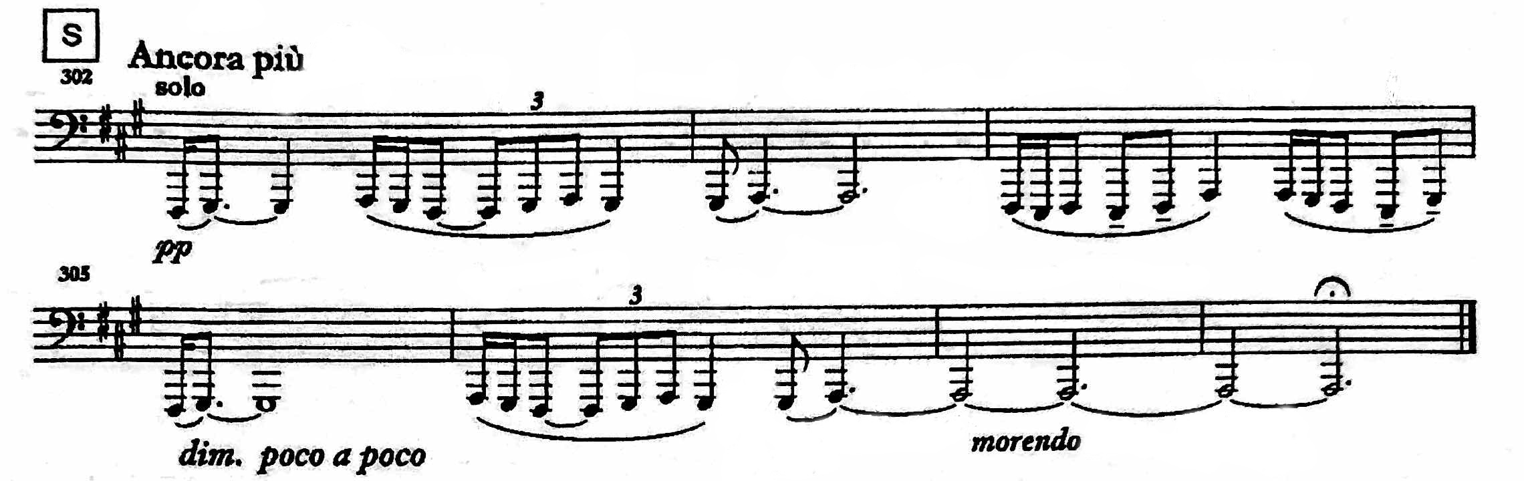

- Symphony in B flat (Hindemith), Movement I: bar 123 to letter K
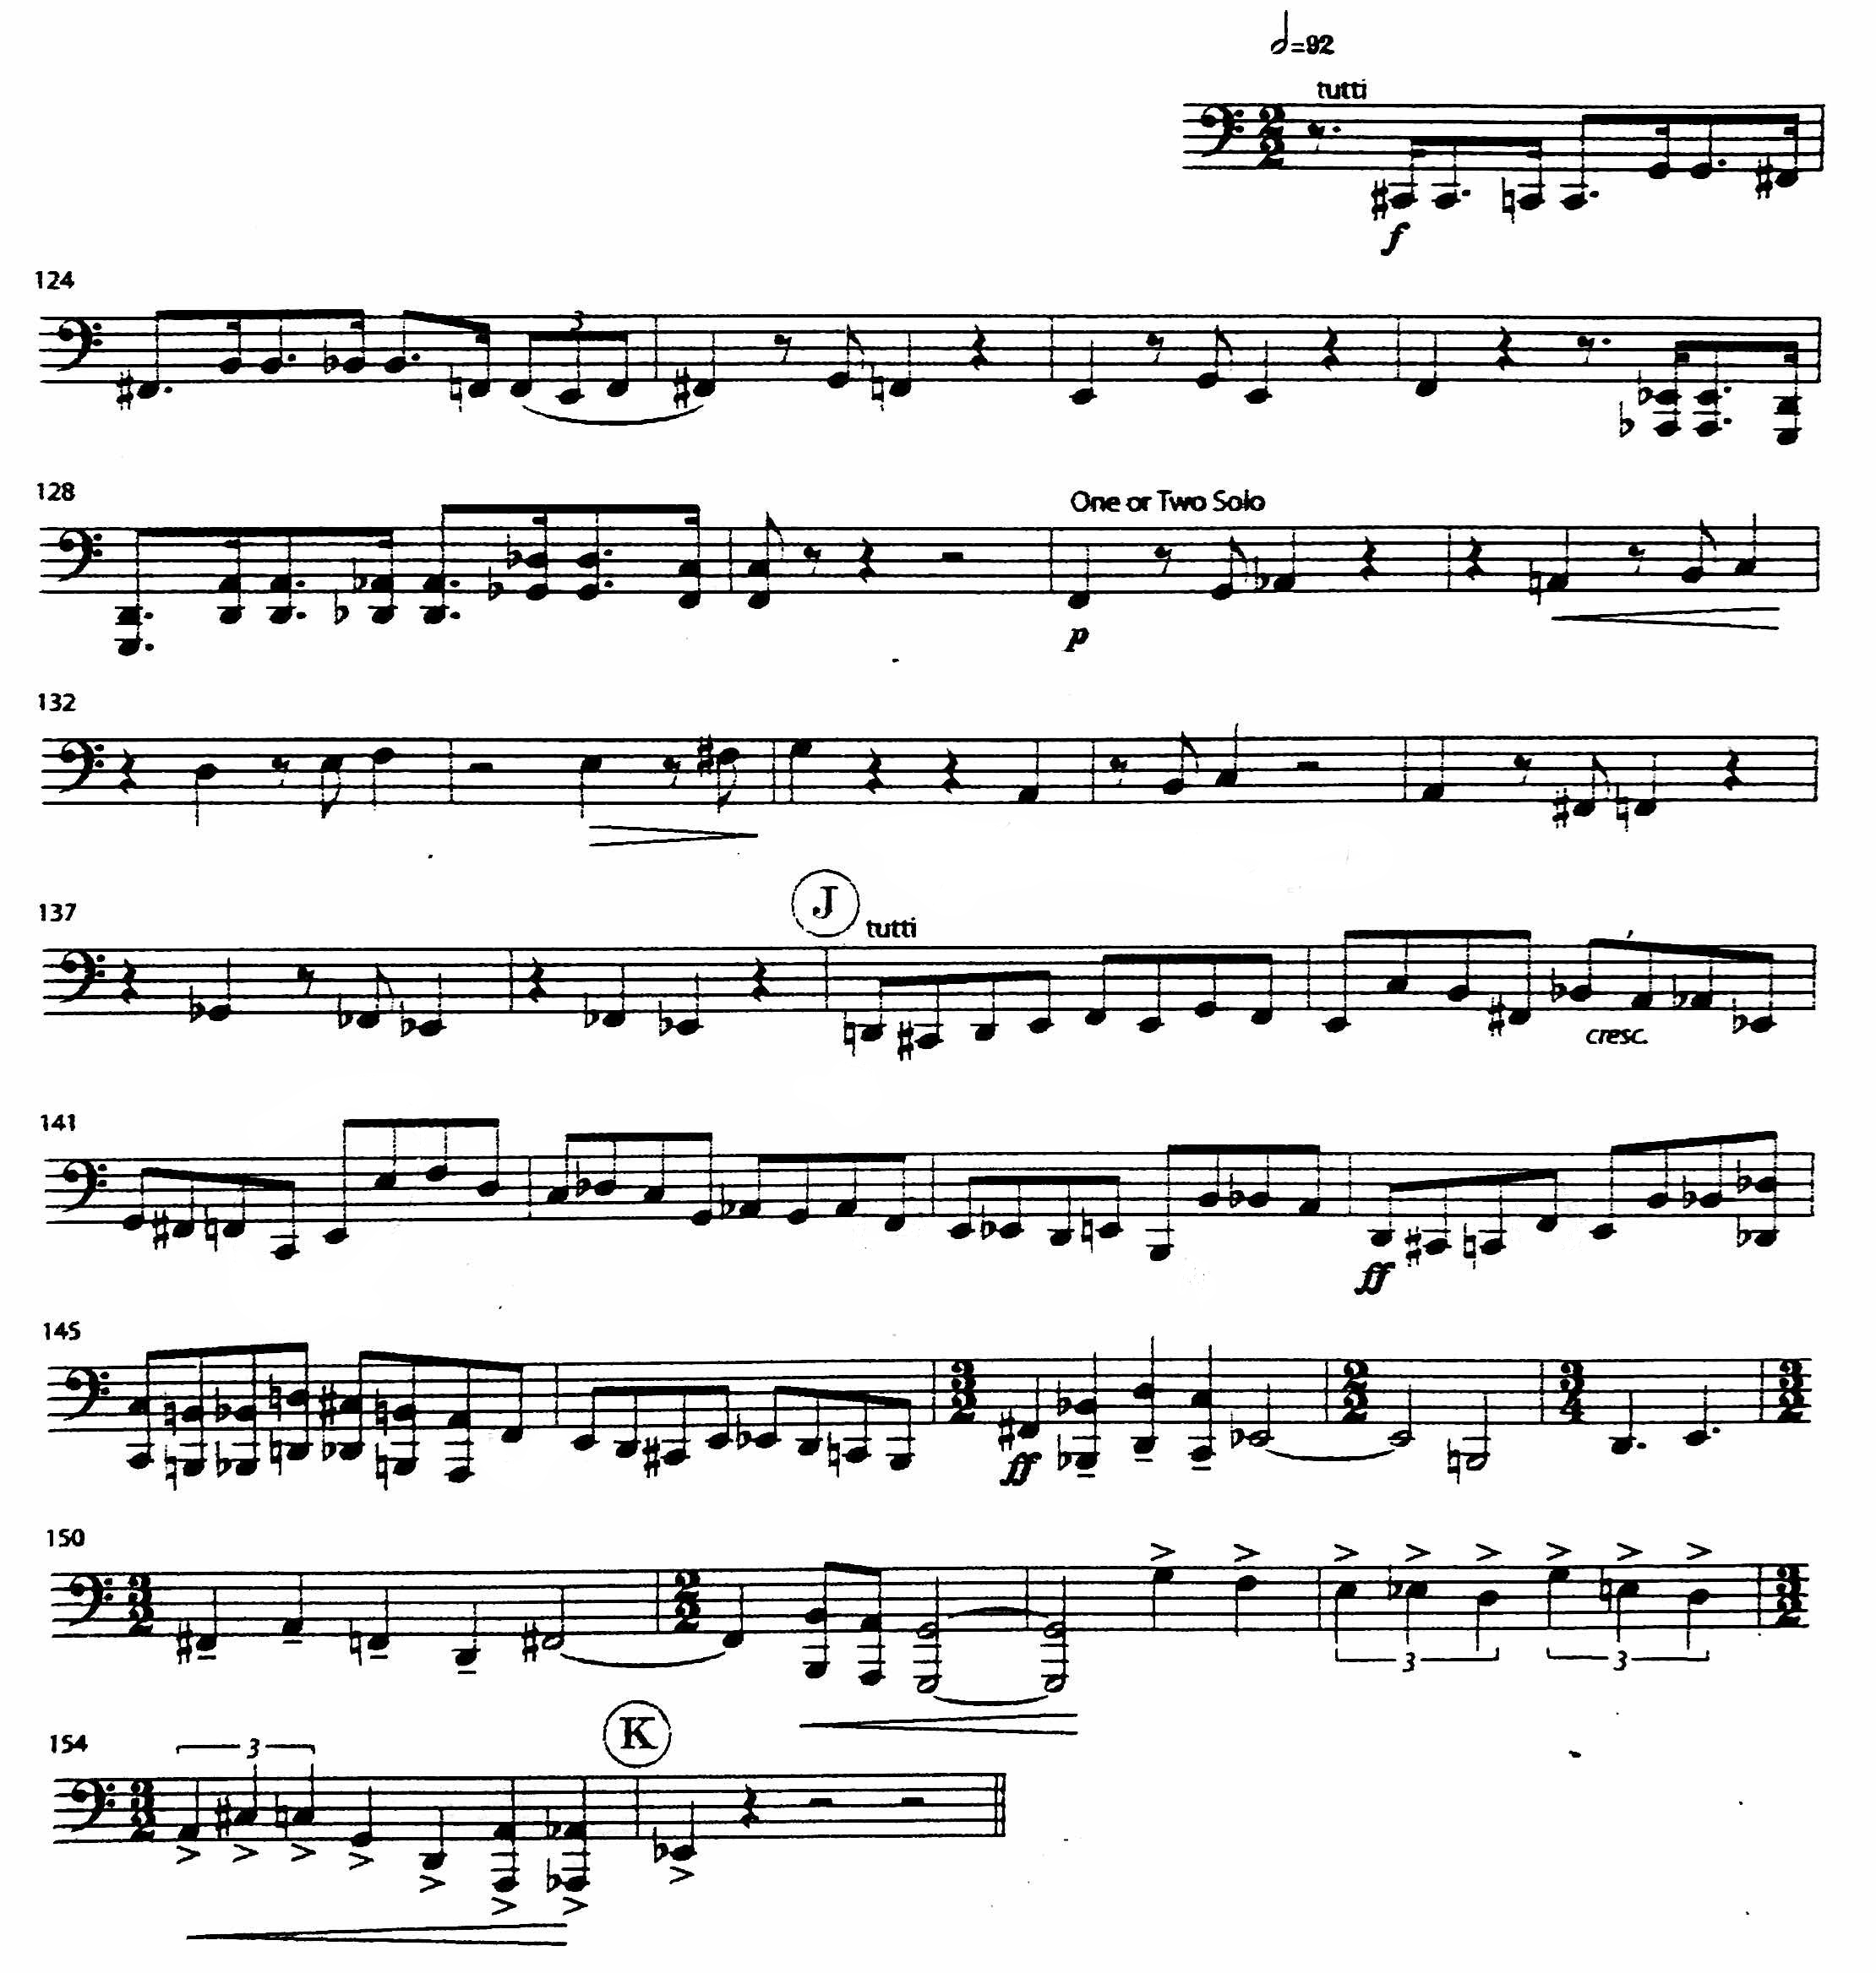

- Symphony in B flat (Hindemith), Movement I: bar 203 to bar 212
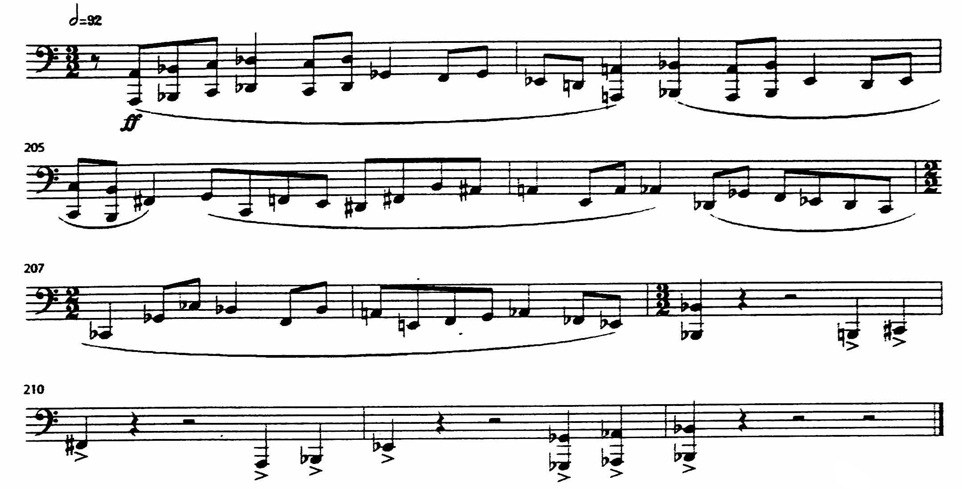
- Eternal Father, Strong to Save (Claude T. Smith): letter H to 7 bars after letter I
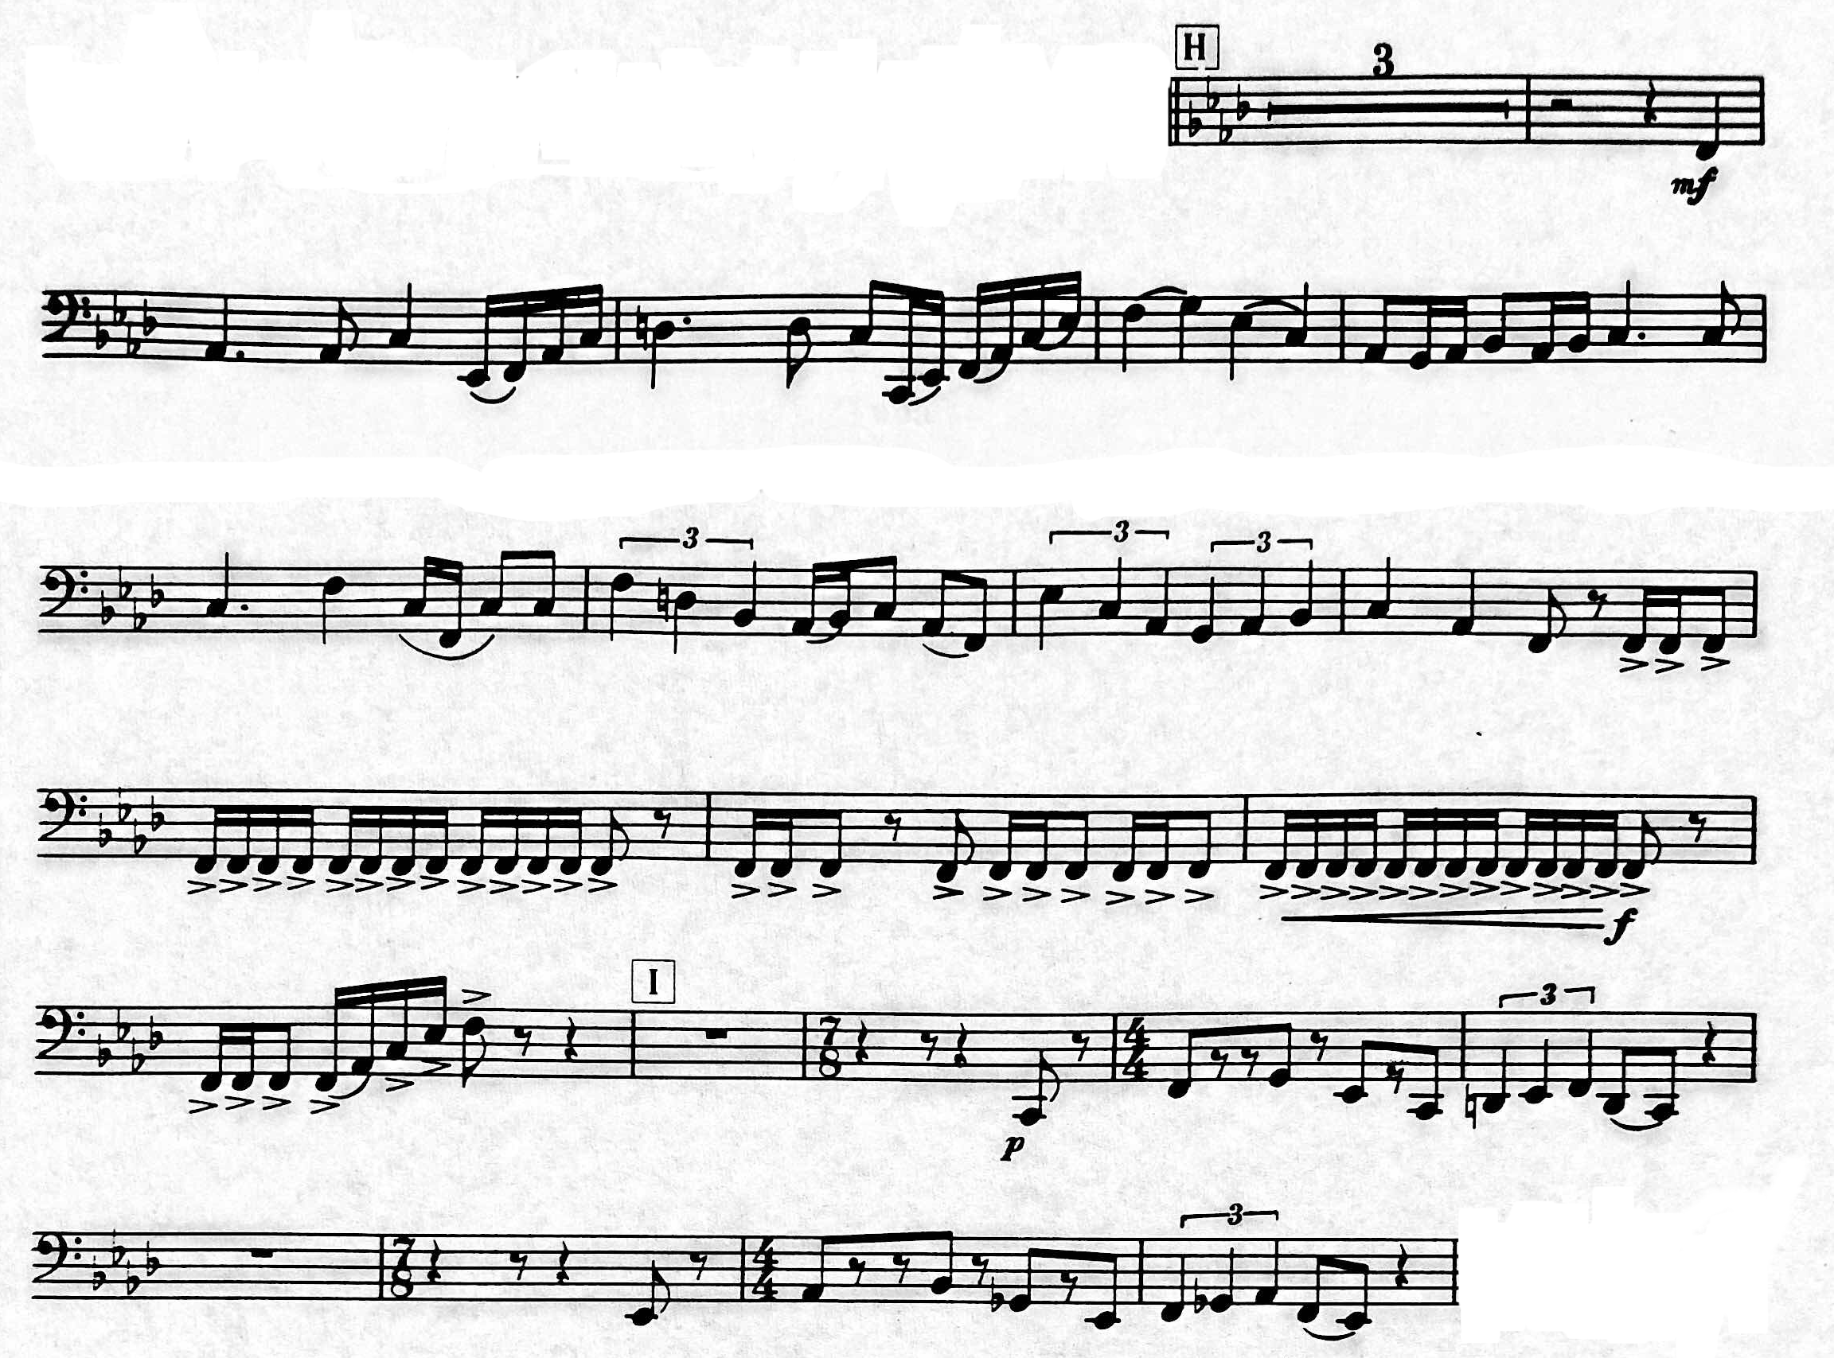
- Lincolnshire Posy (Grainger) Rufford Park Poachers: pick-up to bar 51 to bar 83
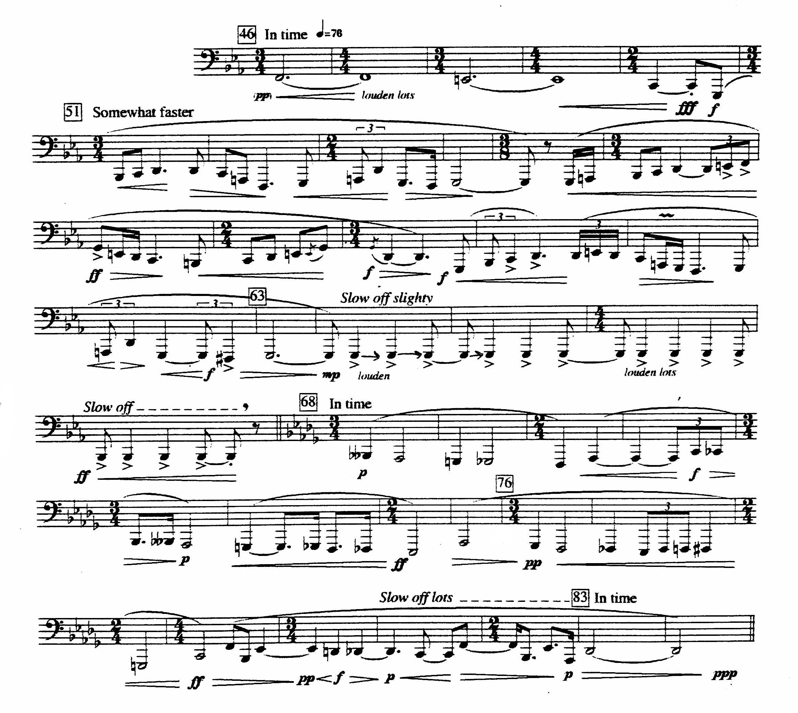
- Overture to Rienzi (Wagner/Patterson)
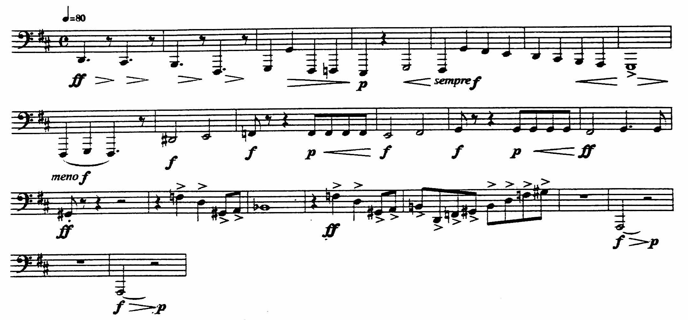
- Overture to Rienzi (Wagner/Patterson)
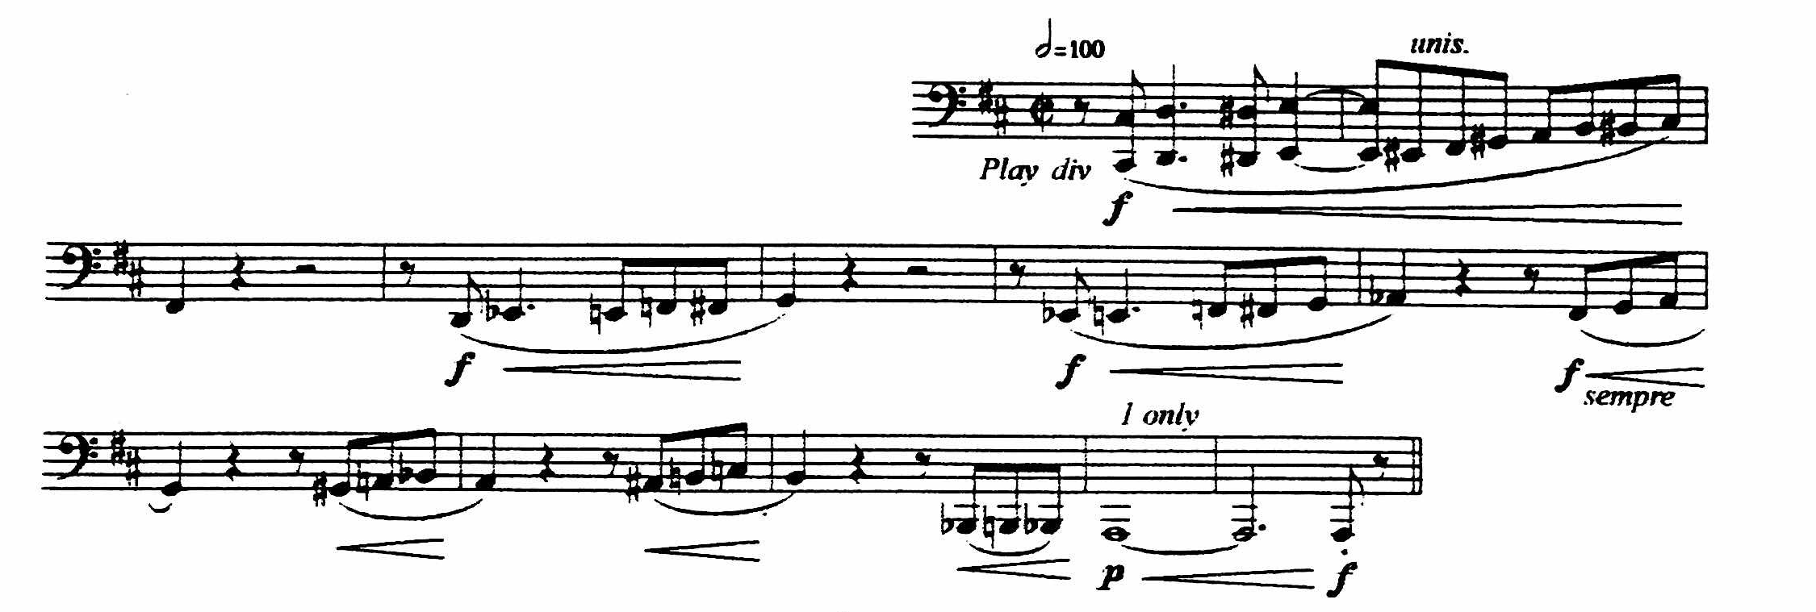
- Toccata Marziale (Vaughan Williams)
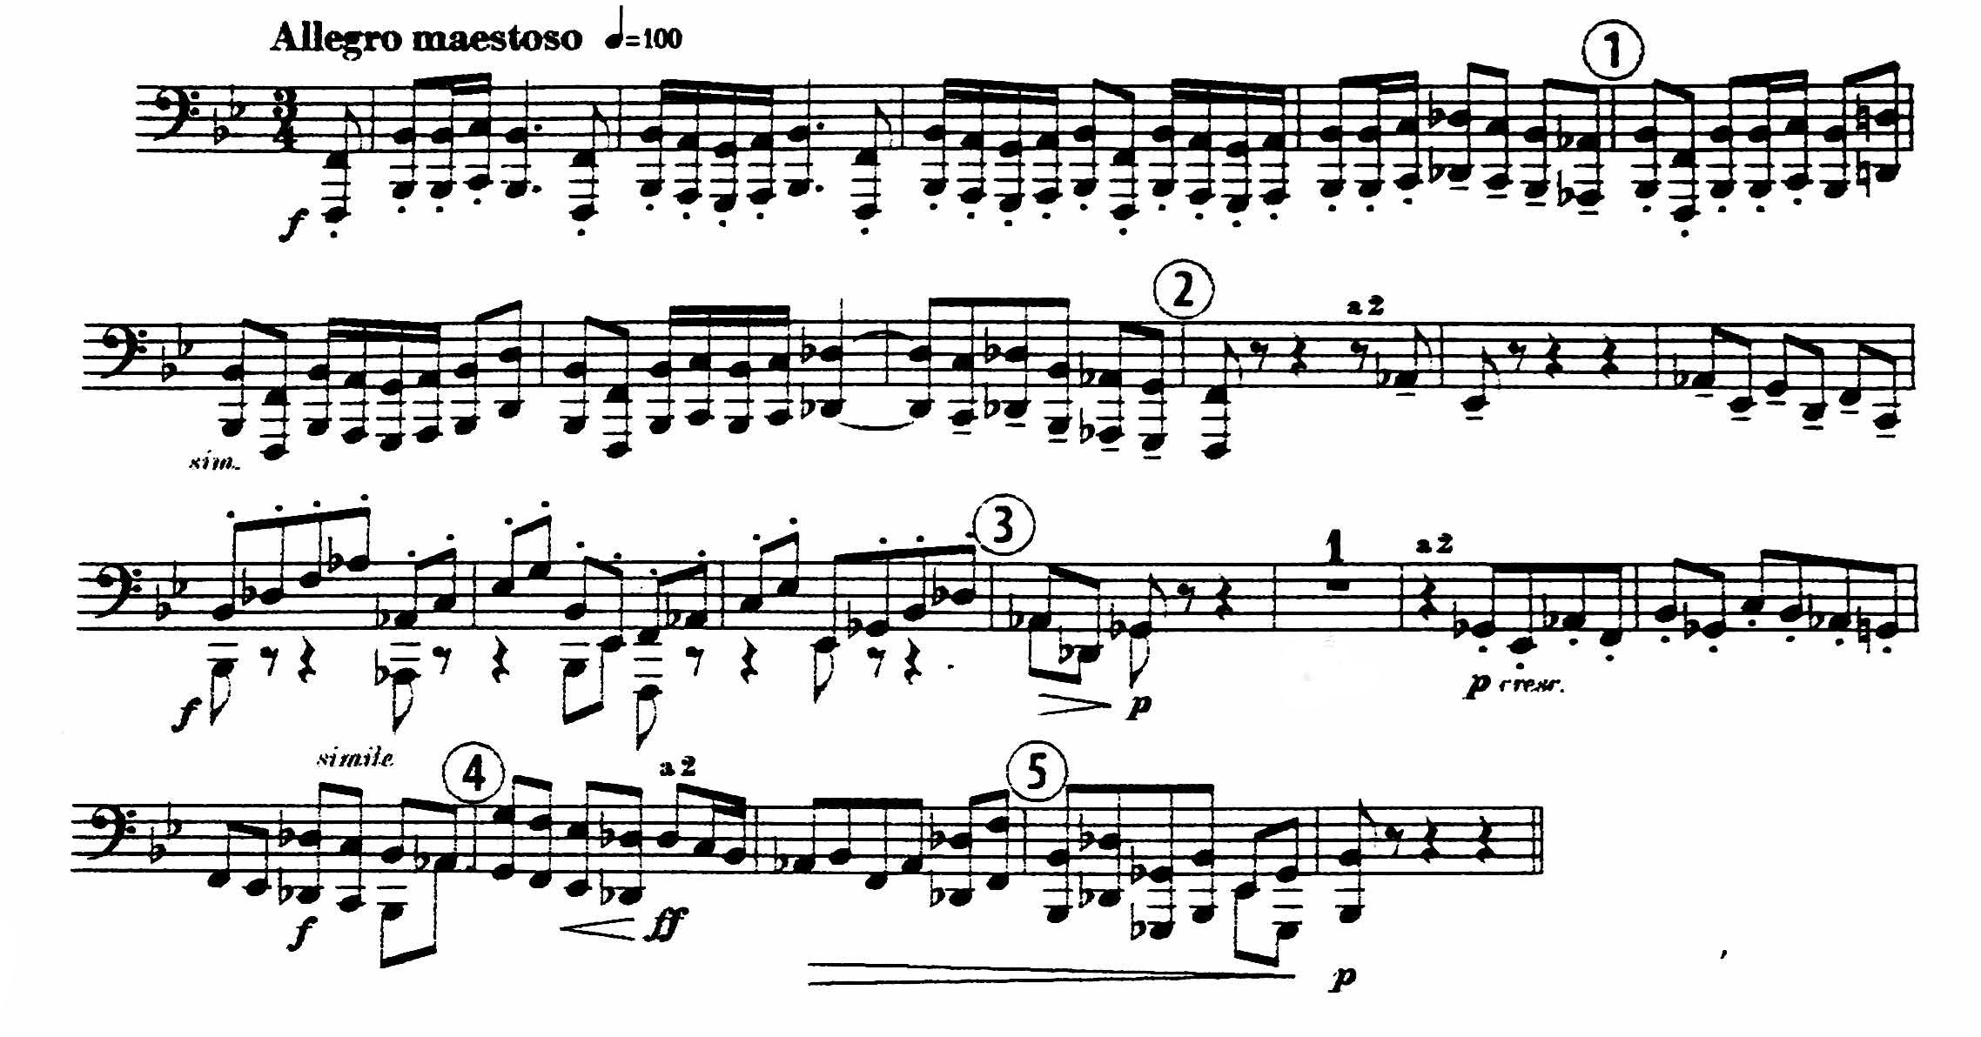
- Toccata Marziale (Vaughan Williams)
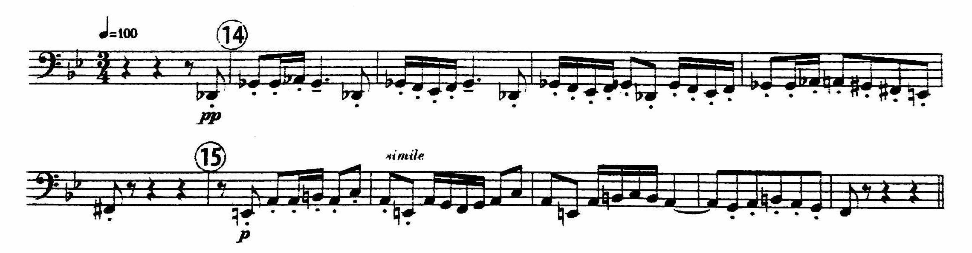

- March, “Entry of the Gladiators” (Fucik/Tuschla)
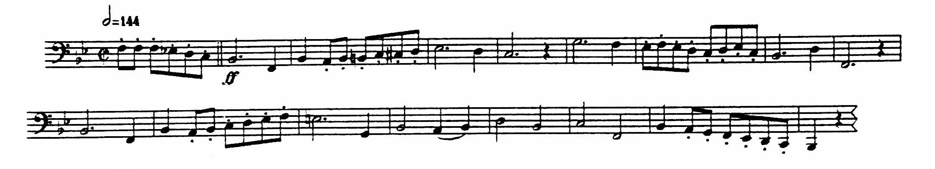

- March, “Entry of the Gladiators” (Fucik/Tuschla)
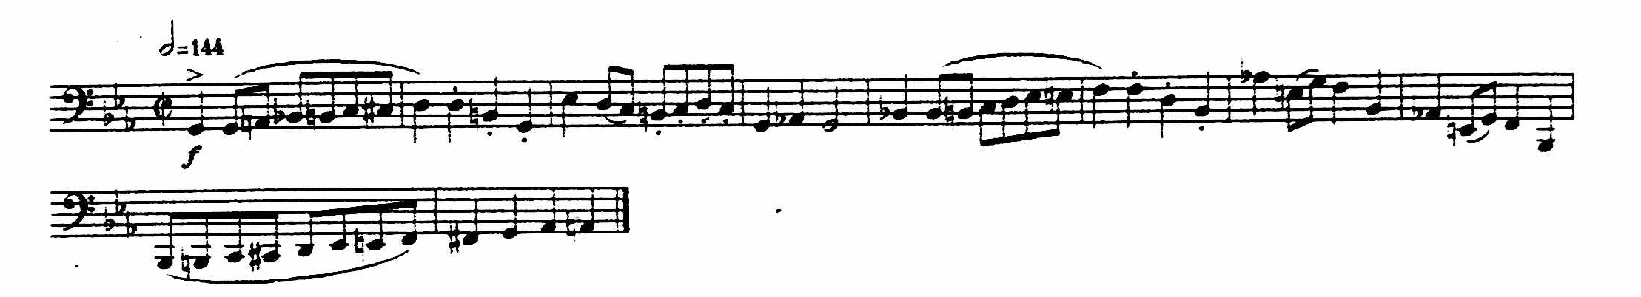

- Music from Far and Away (John Williams): bar 180 to bar 228
